**Java Assignment**

**Name:** Kaustubh N. Kulkarni **Div:** A

**Roll no:** 1911027

-------------------------------------------------------------------------------------------------------

**Q) Write a program for Thread creation by extending Thread class**

/**

* Q 1 ) Write a program for Thread creation by extending Thread class

*/

package com.practical;

public class example_Thread extends Thread{

public static void main(String[] args) {

Thread te = new Thread();

Thread t1 = new Thread(te,"MCA");

Thread t2 = new Thread(te,"BCA");

Thread t3 = new Thread(te,"MBA");

t1.setPriority(Thread.NORM_PRIORITY);

t2.setPriority(Thread.MIN_PRIORITY);

t3.setPriority(Thread.MAX_PRIORITY);

t1.start();

t2.start();

t3.start();

}

public void run() {

System.out.println("Current Thread ID- " + Thread.currentThread().getId() + " For Thread- " + Thread.currentThread().getName());

}

}

**Output:**

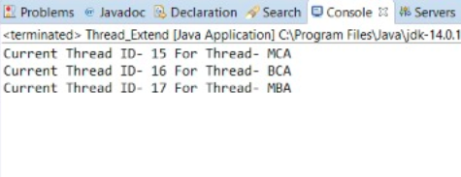

**Q) Write a program Thread creation by implementing Runnable Interface**

/**

* Write a program Thread creation by implementing Runnable Interface

*/

package com.practical;

public class runnable implements Runnable{

public static void main(String[] args) {

Thread tr=new Thread();

Thread t1 = new Thread(tr,"Mumbai");

Thread t2 = new Thread(tr,"Nagpur");

Thread t3 = new Thread(tr,"Pune");

t1.setPriority(6);

t2.setPriority(8);

t3.setPriority(4);

t1.start();

t2.start();

t3.start();

}

public void run(){

System.out.println("Thread ID is " + Thread.currentThread().getId() + " & Thread Name is " + Thread.currentThread().getName());

}

}

**Output:**

